Dis-Mex-Vera Cruz-Classic-Head-600 CE

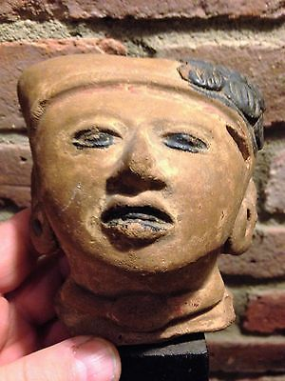

Formal Label: Vera Cruz Classic Head

Accession Number:

**LC Classification:**

Date or Time Horizon: 100-1000 CE

Geographical Area: north and central areas of the present-day **Mexican** state of Veracruz

**Map:** https://upload.wikimedia.org/wikipedia/commons/thumb/b/b9/Classic_sites_1.png/525px-Classic_sites_1.png

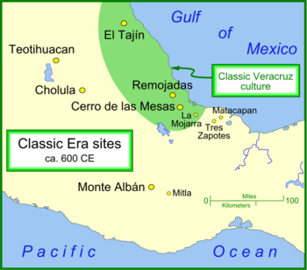

Cultural Affiliation: Veracruz

Media: terracotta, charcoal pigment around head ornament, eyes, mouth

Dimensions:

Weight:

Condition:

Provenance:

**References:**

**Discussion:**